PROJECT TITLE: CRM Application for Jewel Management

# College Name: Navarasam Arts and Science College For Women

### College Code: bru3a

TEAM ID: 0CBD569BD35DA0D828047F22521C578B

# TEAM MEMBERS:

Team Leader Name: Harivarshini R

Email: harivarshinigopal@gmail.com

Team Member1: Viji P

Email: Vijip9796@gmail.com

Team Member2: Deepa S

Email: deepammk2005@gmail.com

Team Member3: Sudharshana S

Email: sudharshanasaminathan1011@gmail.com

# Title:- CRM Application for Jewel Management - (Developer)

Project Overview: Jewelry businesses face challenges in managing customer preferences, inventory, billing, and after-sales services. This project leverages Salesforce CRM to build an application that streamlines customer relationship management, sales tracking, and inventory handling for jewelry shops. The system connects customers, sales staff, and administrators on a single platform to enhance operational efficiency and customer satisfaction.

Using custom objects, flows, Apex triggers, and dashboards, the system automates tasks such as order management, inventory updates, customer communication, and loyalty tracking. The project demonstrates how Salesforce can be tailored to industry-specific needs, ensuring better customer engagement and growth in the jewelry business.

### Objectives :

* Customer Management: Maintain detailed customer profiles including purchase history, preferences, and loyalty points.
* Inventory Tracking: Monitor stock availability in real-time to prevent shortages and overstock.
* Sales Automation: Automate quotation generation, billing, and follow-up reminders.
* Service Management: Provide after-sales services like product maintenance, repair requests, and warranty tracking.
* Analytics & Reporting: Generate dashboards and reports for sales, customer trends, and revenue insights.
* Student Outcomes :
* Hands-on Salesforce Development: Gain experience in creating custom objects, fields, relationships, flows, and triggers specific to jewelry business needs.
* End-to-End CRM Project Understanding: Learn the full cycle from requirement gathering to deployment in a real-world business use case.
* Analytical & Problem-Solving Skills: Develop the ability to analyze business challenges and design Salesforce-based solutions.
* Collaboration & Documentation Skills: Work as a team plan, build, test, and document CRM functionalities.
* Industry Exposure: Understand how CRM systems like Salesforce

System Requirements :

Hardware Requirements:

* + - * Computer with min/sum 4 GB RAM, Dual-core processor
      * Stable internet connection

Software Requirements:

* Salesforce Developer Edition Org
* Modern Web Browser (e.g., Google Chrome, Firefox)

Project Duration : 31 Hours;

Phases Overview :

|  |  |  |  |
| --- | --- | --- | --- |
| Phase No. | Phase Name | Description | Page Numbers |
| 1 | Requirement Analysis & Planning | Collect requirements from jewelry business stakeholders; define scope, goals, data model, and workflows. | **5** |
| 2 | Salesforce Development | Create custom objects (Customer, Product, Order, Inventory), fields, relationships; set up flows and triggers for automation. | **5-14** |
| 3 | UI/UX Development & Customization | Build Lightning App, customize page layouts, record pages, add fields, and implement user-friendly interfaces. | **14-29** |
| 4 | Data Migration, Testing & Security | Configure Users, Profiles, Roles, Sharing Rules; create Reports & Dashboards; test all CRM functionalities. | **29-43** |
| 5 | Deployment, Documentation & Maintenance | Deploy the CRM application, finalize the Home Page, prepare documentation, conclusion, and maintenance plan. | **43-50** |

Phase 1: Requirement Analysis & Planning:-

* CRM for Jewelry Management using Salesforce focuses on creating a digital system to manage customers, sales, and inventory efficiently. Requirements are gathered from jewelers and customers to ensure smooth end-to-end operations.

Phase 2: Salesforce Development – Backend & Configurations:

* Development of custom objects like Customer, Jewelry Product, Orders, and Inventory with automation using Flows and Triggers to handle stock updates, billing, and customer communication.

# Milestone 1: Salesforce developer account creation

# Activity 1: Creating Developer Account

Creating a developer org in salesforce.

1. Go to <https://developer.salesforce.com/signup>

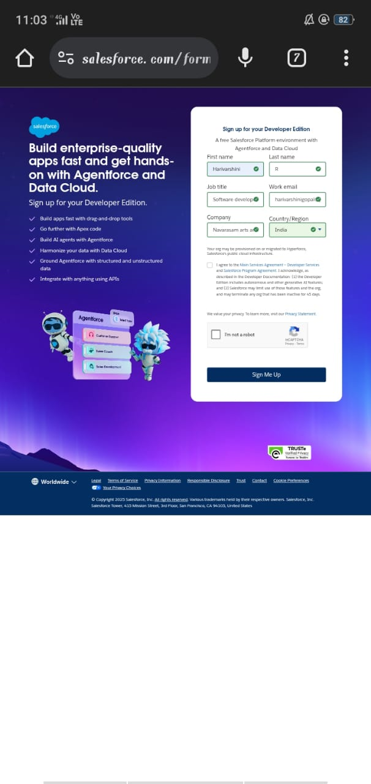

1. On the sign up form, enter the following details :

1. First name & Last name

2. Email

3. Role : Developer

4. Company : College or Company Name

5. County : India

6. Postal Code : pin code

7. Username : should be a combination of your name and company

This need not be an actual email id, you can give anything in the format : username@organization.com

Click on sign me up after filling these.

# Activity 2: Account Activation

* Go to the inbox of the email that you used while signing up. Click on the verify account to activate your account. The email may take 5-10mins.

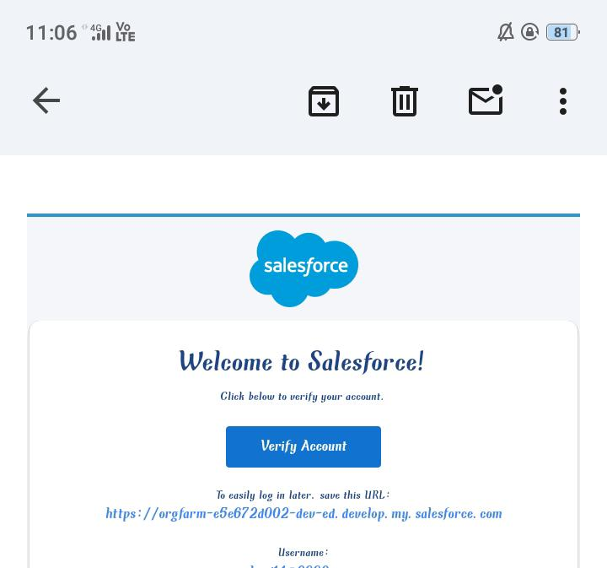

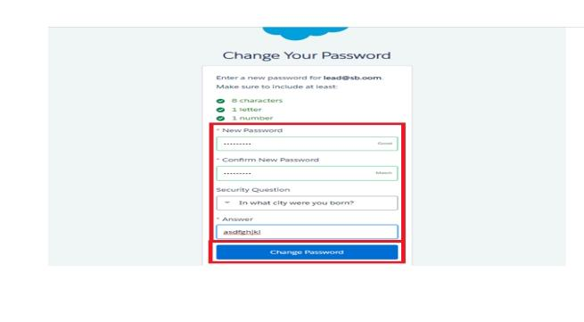

1. Click on Verify Account

2. Give a password and answer a security question and click on change password.

3.Then you will redirect to your salesforce setup page.

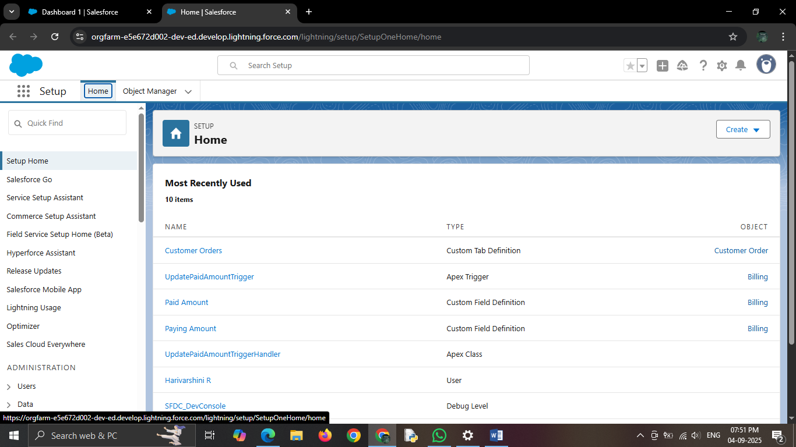

# Milestone 2 : OBJECT :-

# Activity 1: Create Jewel Customer Object :-

To create an object:

1. From the setup page >> Click on Object Manager >> Click on Create >> Click on Custom Object.

a) Enter the label name >>  Jewel Customer

b) Plural label name >>  Jewel Customers

c) Enter Record Name Label and Format

● Record Name >> Customer name

● Data Type >> Text

2. Click on Allow reports and Track Field History,Allow Activities.

3. Allow search >> Save.

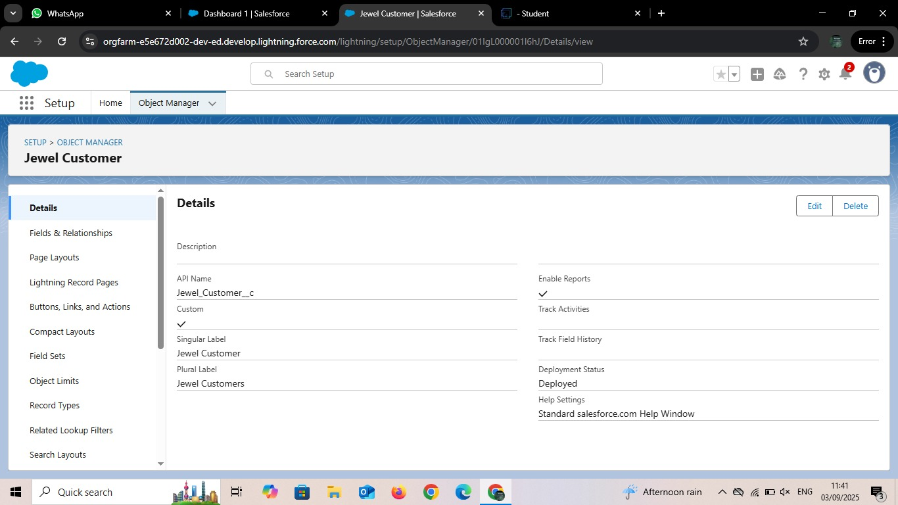

# Activity 2:Create Item Object:-

To create an object:

1. From the setup page >> Click on Object Manager >> Click on Create >> Click on Custom Object.

a) Enter the label name >> Item

b) Plural label name >> Items

c) Enter Record Name Label and Format

● Record Name >> Item Name

● Data Type >> Auto Number

2. Click on Allow reports and Track Field History,Allow Activities.

3. Allow search >> Save.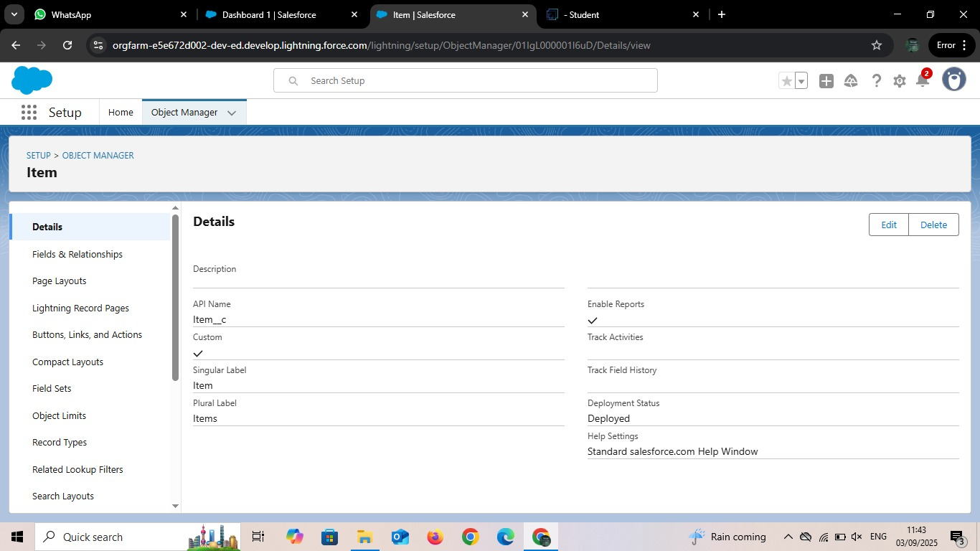

# Activity 3:Create Customer Order:-

To create an object:

1. From the setup page >> Click on Object Manager >> Click on Create >> Click on Custom Object.

a) Enter the label name >> Customer Order

b) Plural label name >> Customer Orders

c) Enter Record Name Label and Format

● Record Name >> Customer Order Name

● Data Type >> Auto Number

* Display Format >> Item-{00}
* Starting Number >> 1

2. Click on Allow reports and Track Field History,Allow Activities.

3. Allow search >> Save.

# Activity 3:Create Price object:-

To create an object:

1. From the setup page >> Click on Object Manager >> Click on Create >> Click on Custom Object.

a) Enter the label name >> Price

b) Plural label name >> Prices

c) Enter Record Name Label and Format

● Record Name >> Customer Order Name

● Data Type >> Auto Number

* Display Format >> Price -{00}
* Starting Number >> 1

2. Click on Allow reports and Track Field History,Allow Activities.

3. Allow search >> Save.

# Activity 3:Create Billing object:-

To create an object:

1. From the setup page >> Click on Object Manager >> Click on Create >> Click on Custom Object.

a) Enter the label name >> Billing

b) Plural label name >> Billings

c) Enter Record Name Label and Format

● Record Name >> Customer Order Name

● Data Type >> Auto Number

* Display Format >> Billing -{00}
* Starting Number >> 1

2. Click on Allow reports and Track Field History,Allow Activities.

3. Allow search >> Save.

# Milestone 3 : TABS :-

What is Tab : A tab is like a user interface that is used to build records for objects and to view the records in the objects.

# Activity 1: Creating a Customer Order Tab:-

To create a Tab :( Jewel Customer)

1 .Go to setup page >> type Tabs in Quick Find bar >> click on tabs >> New (under custom object tab)

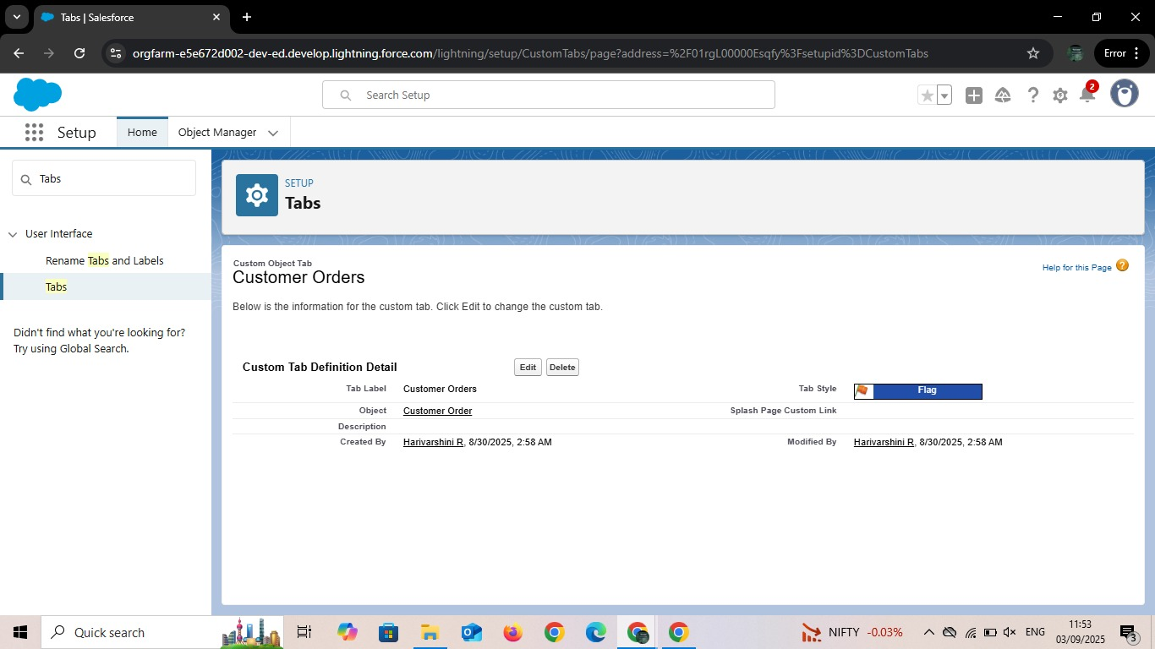

1. Select Object(Jewel Customer) >> Select any tab style >> Next (Add to profiles page) keep it as default >> Next (Add to Custom App) keep it as default
2. >> Save.

# Activity 2: Creating a Tab:(Item)

1. Go to setup page >> type Tabs in Quick Find bar >> click on tabs >> New (under custom object tab)
2. Select Object(Item) >> Select the tab style >> Next (Add to profiles page) keep it as default
3. >> Next (Add to Custom App) keep it as default
4. >> Save.

# Activity 3: Creating a Tab:( Customer Order)

1. Go to setup page >> type Tabs in Quick Find bar >> click on tabs >> New (under custom object tab)
2. Select Object(Customer Order) >> Select the tab style >> Next (Add to profiles page) keep it as default
3. >> Next (Add to Custom App) keep it as default
4. >> Save.

# Activity 4: Creating a Tab:( Price)

1. Go to setup page >> type Tabs in Quick Find bar >> click on tabs >> New (under custom object tab)
2. Select Object(Price) >> Select the tab style >> Next (Add to profiles page) keep it as default
3. >> Next (Add to Custom App) keep it as default
4. >> Save.

# Activity 5: Creating a Tab:( Billing)

1. Go to setup page >> type Tabs in Quick Find bar >> click on tabs >> New (under custom object tab)
2. Select Object(Billing) >> Select the tab style >> Next (Add to profiles page) keep it as default
3. >> Next (Add to Custom App) keep it as default
4. >> Save.

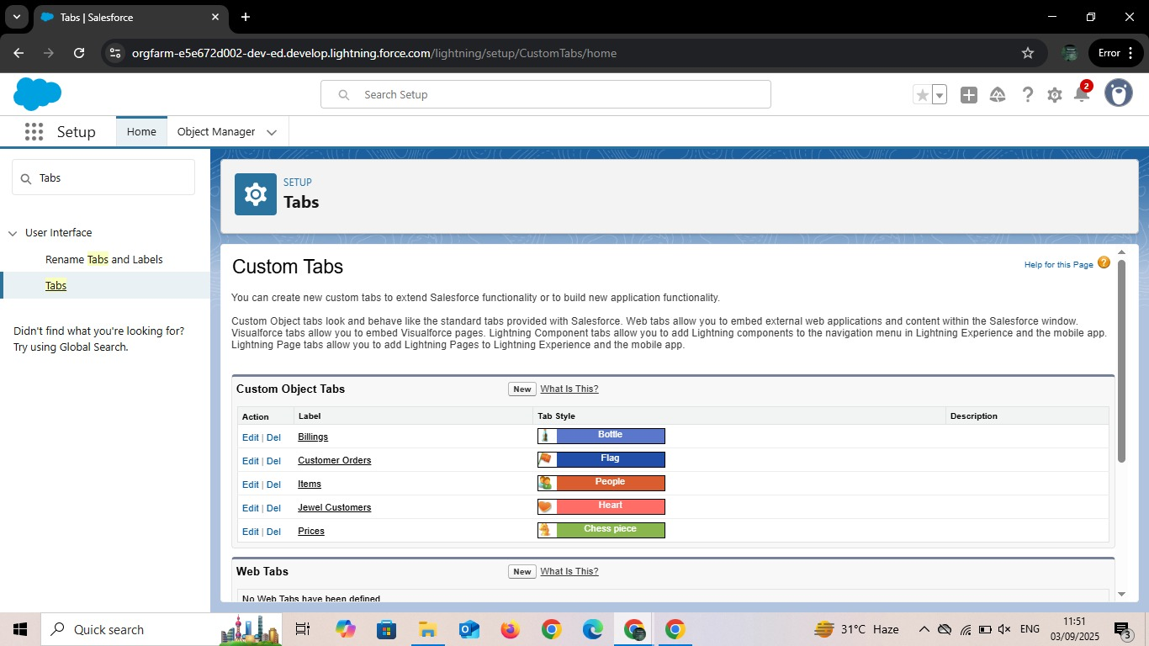

PHASE 3: UI/UX Development & Customization

## Milestone 4: THE LIGHTNING APP:-

# Create a Lightning App:

To create a lightning app page

1. Go to setup page >> search “app manager” in quick find >> select “app manager” >> click on New lightning App.
2. click on New lightning App.
3. Fill the app name in app details and branding as follow  
    App Name : Jewellery Inventory System.  
    Developer Name : This will auto populated  
    Description : Elevate your look with elegance
4. Image : optional (if you want to give any image you can otherwise not mandatory)  
    Primary colour hex value : keep this default.

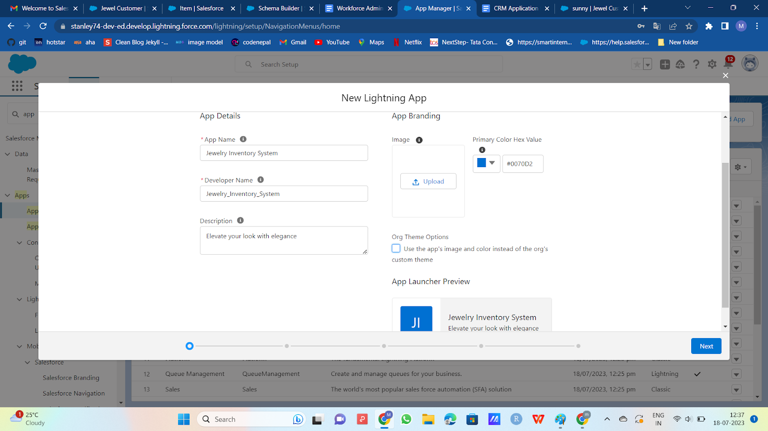

1. Then click Next  >> (App option page)Set Navigation Style as Console Navigation >> Next.
2. (Utility Items) keep it as default >> Next.
3. To Add Navigation Items:
4. Search for the item in the (JewelCustomer,Item,CustomerOrder,Price,Billing,Reports, Dashboard) from the search bar and move it using the arrow button ? Next? Next.

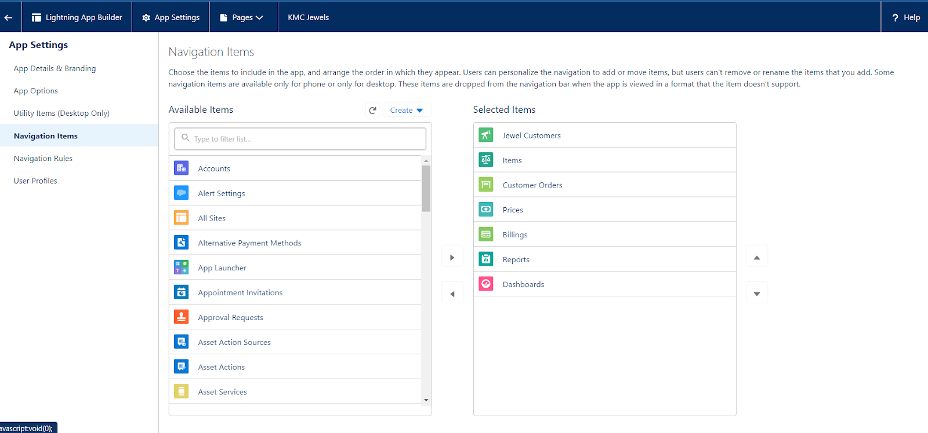

1. To Add User Profiles:
2. Search profiles (System administrator) in the search bar >> click on the arrow button >> save & finish.

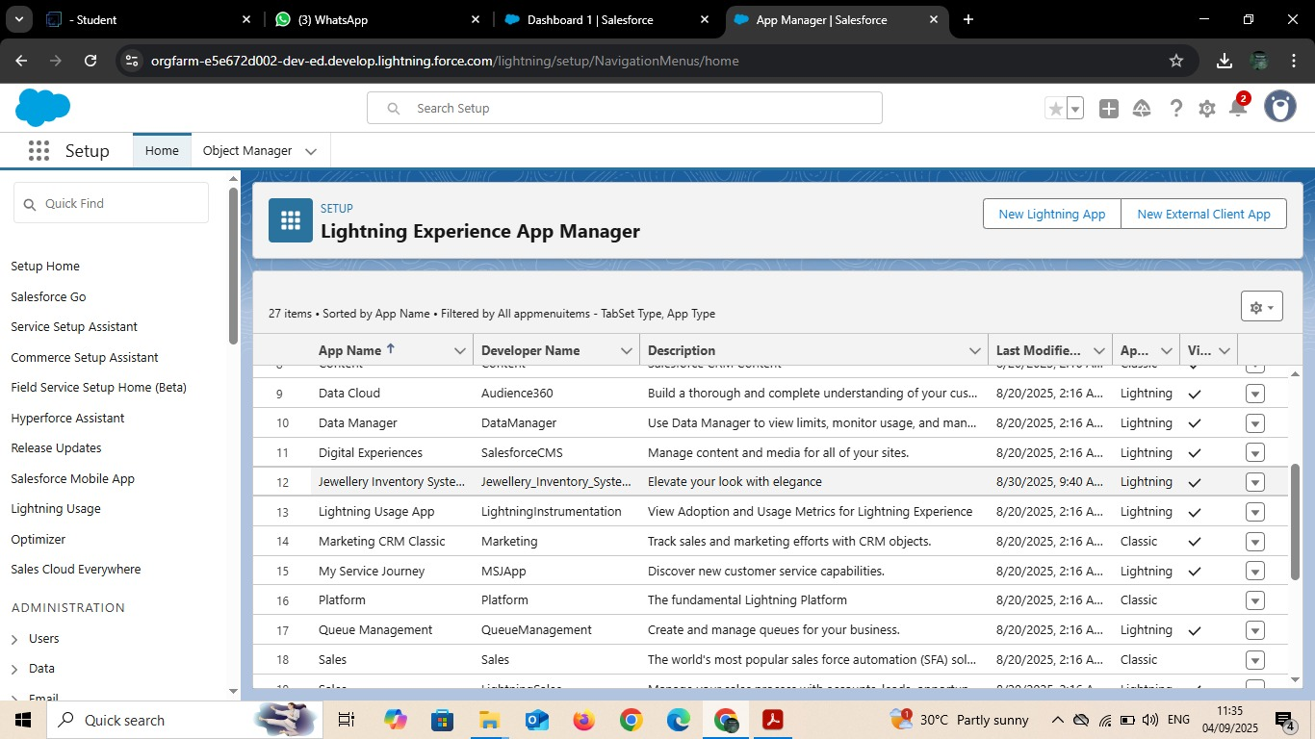

## Milestone 5: FIELDS :-

### Creating Lookup Relationship:-

1. Go to the setup page >> click on object manager >> type object name(Customer Order) in the quick find bar >> click on the object.
2. Click on fields & relationship >> click on New.
3. Select “Lookup relationship” as data type and click Next.
4. Select the related object “ Jewel Customer ”.
5. Give Field Label as “Customer” and click Next.
6. Next >> Next >> Save.

### C:\Users\Admin\Pictures\Screenshots\Screenshot (5).png

### Creating a Master-Detail Relationship

1. Go to the setup page >> click on object manager >>  type object name(Customer Order) in the quick find bar >> click on the object.

2.Click on fields & relationships >> click on New.

3.Select “Master-Detail relationship” as data type and click Next.

4.Select the related object “ Item”.

5.Give Field Label as “Item” and click Next.

6.Next >> Next >> Save.

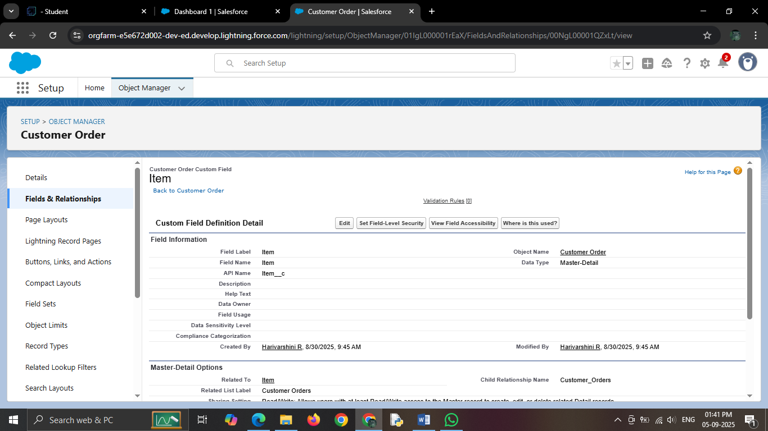

### Creating Text Field in Jewel Customer Object

To create fields in an object:

1. Go to setup >> click on Object Manager >> type object name(Jewel Customer ) in quick find bar >> click on the object.
2. Now click on “Fields & Relationships” >> New
3. Select Data type as “Text”.
4. Click on Next
5. Fill the above as following:
6. Field Label: City
7. Length : 20
8. Field Name : gets auto generated
9. Click on Next >> Next >> Save and new.

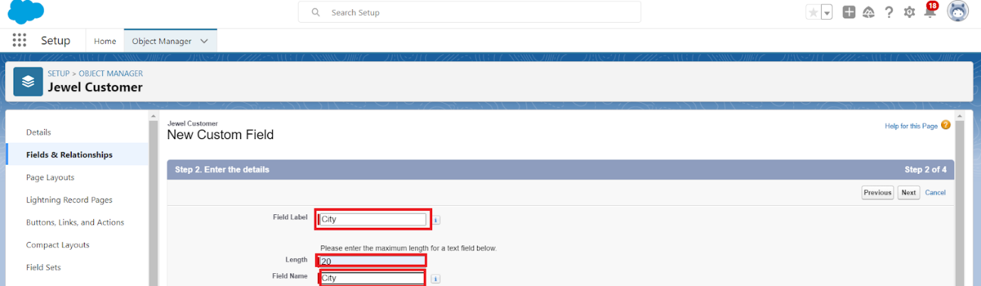

### Creating the Phone field in object Jewel Customer

To create fields in an object:

1. Go to setup >> click on Object Manager >> type object name(Jewel Customer ) in quick find bar >> click on the object.
2. Now click on “Fields & Relationships” >> New
3. Select Data type as “Phone” and click Next.
4. Given the Field Label as “ Phone”.

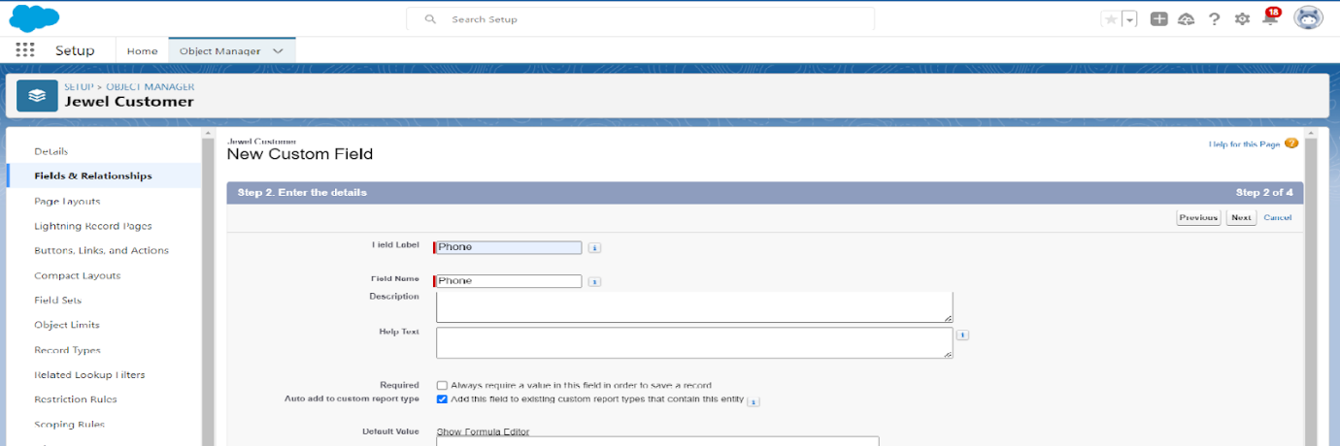

1. Field Name will be auto populated, and click on Next >> Next >> Save & new.

### Creating the Email field in object Jewel Customer

To create fields in an object:

1. Go to setup >> click on Object Manager >> type object name(Jewel Customer ) in quick find bar >> click on the object.
2. Now click on “Fields & Relationships” >> New
3. Select Data type as “Email” and click Next.
4. Given the Field Label as “ Email”.
5. Field Name will be auto populated, and click on Next >> Next >> Save.

### Creating the number field in Item object

To create fields in an object:

1. Go to setup >> click on Object Manager >> type object name(Item) in quick find bar? click on the object.
2. Now click on “Fields & Relationships” >> New
3. Select Data type as “Number” and click Next.
4. Given the Field Label as “ Purity” and length as “ 2 ”.

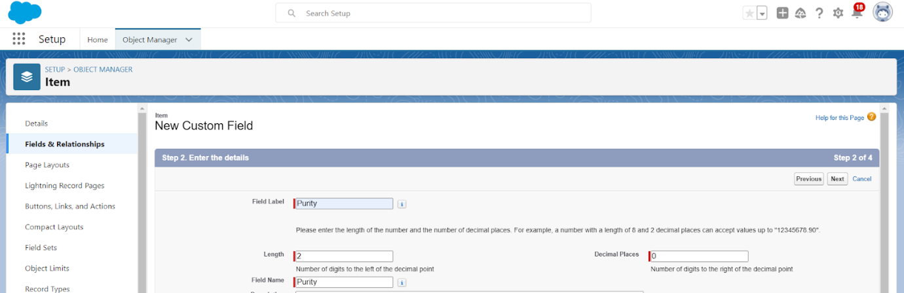

1. Field Name will be auto populated, and click on Next >> Next >> Save.

### Creating Picklist Field in Item Object

To create fields in an object:

1. Go to setup >> click on Object Manager >> type object name(Item) in quick find bar>> click on the object.
2. Now click on “Fields & Relationships” >> New.
3. Select Data type as “Picklist” and click Next.
4. Enter Field Label as “Item Type”.
5. In values select “Enter values(Gold,Silver), with each value separated by a new line" and enter values as shown below.

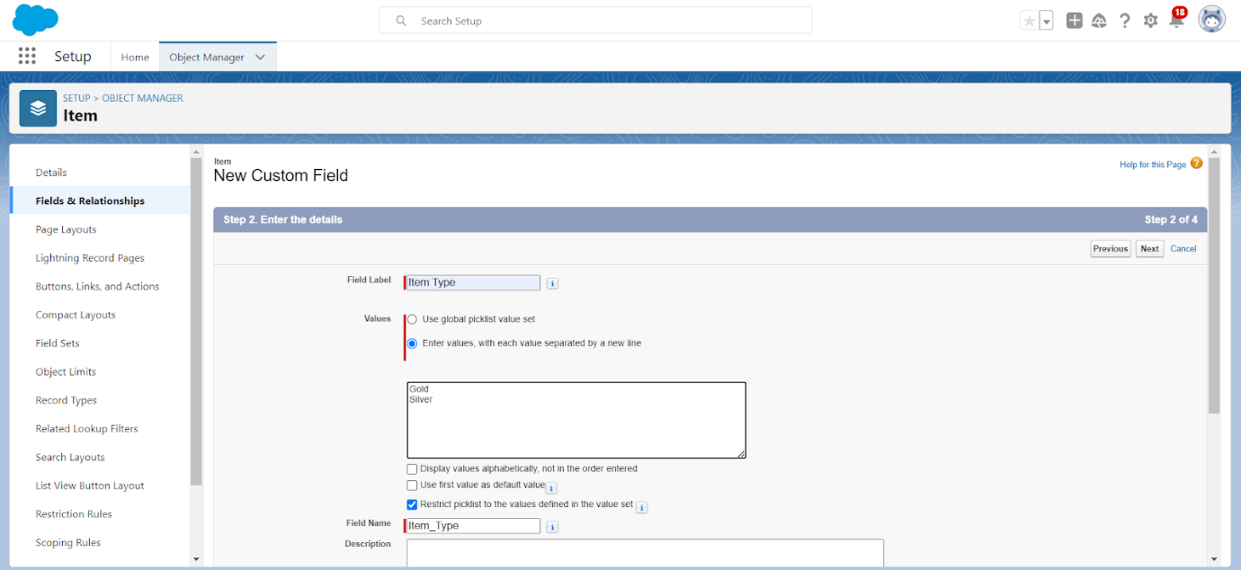

1. Click Next? Next ? Next ? Save .

### Creating Currency Field in Price Object

To create fields in an object:

1. Go to setup >> click on Object Manager >> type object name(Price) in quick find bar >> click on the object.
2. Now click on “Fields & Relationships” >> New.
3. Select Data type as “Currency” and click Next.
4. Enter Field Label as “Gold Price” and length as “ 8”and decimal 0.Field name will be auto generated.
5. Click Next >> Next >> Next >> Save .

### Creating Formula Field(Cross Object) in Item Object

create fields in an object:

1. (Go to setup >> click on Object Manager >> type object name(Item) in quick find bar? click on the object.
2. Now click on “Fields & Relationships” >> New.
3. Select Data type as “Formula” and click Next.
4. Give Field Label and Field Name as “Gold Price” and select formula return type as “Currency” and click next.

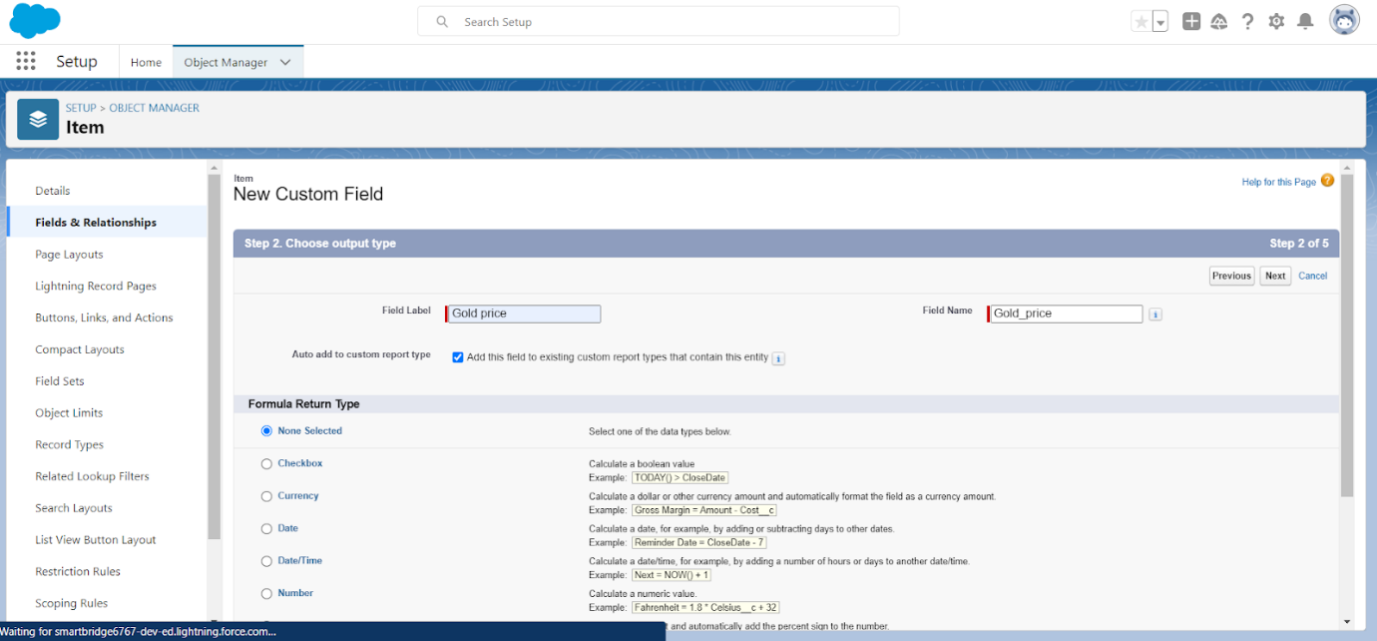

1. Under Advanced Formula write down the formula :Prices\_\_r.Gold\_price\_\_c  / 10.
2. click “Check Syntax” and Next >> Next >> Save.

### Creating Remaining Fields in Objects

1. Go to setup >> click on Object Manager >> type object name(Jewel Customer) in search bar >> click on the object.

* Now click on “Fields & Relationships” >> New

Select Data type as a “Text” and Click on Next

Choose **Data Type**: Text → Click **Next**

Field Label: State

Length: 20

Field Name: auto-fills

Add to Page Layout → Click **Save &New**

* New → Data Type: Text

Field Label: Street

Length: 20

Next → Next → Save

* New → Data Type: Text

Field Label: Country

Length: 18

Next → Next → Save

* New → Data Type: Text

Field Label: Zip/Postal Code

Length: 6

Next → Next → Save

1. Go to setup >> click on Object Manager >> type object name(  
   Price) in search bar >> click on the object.

* Now click on “Fields & Relationships” >> New

Field Name: **Silver Price**

Data Type: **Currency**

Length = **8**

Decimal Places = **5**

Next → Next → Save

1. Go to setup >> click on Object Manager >> type object name(Item) in search bar >> click on the object.

### C:\Users\Admin\Pictures\Screenshots\Screenshot (7).png

1. Go to setup >> click on Object Manager >> type object name(Billing) in search bar >> click on the object.

### C:\Users\Admin\Pictures\Screenshots\Screenshot (8).png

# ACTIVITY :Schema Bulider

### C:\Users\Admin\AppData\Local\Packages\5319275A.WhatsAppDesktop_cv1g1gvanyjgm\TempState\55563844BCD4BBA067FE86AC1F008C7E\WhatsApp Image 2025-09-05 at 15.36.24_6ab2e935.jpg

### ACTIVITY :Creating the Field Dependencies

### C:\Users\Admin\Pictures\Screenshots\Screenshot (9).png

**ACTIVITY :Creating The Validation Rules**

### C:\Users\Admin\Pictures\Screenshots\Screenshot (10).png

## ****Milestone 6: PROFILES****

**ACTIVITY 1: ACTIVITY 2:Worker Profile**

1. Go to Profiles:
   * In Salesforce, go to the Setup menu (the gear icon).
   * In the search box, type Profiles and click on it.
2. Clone a Profile:
   * Find the Salesforce Platform User profile (or any profile you want to copy).
   * Click on the profile and press Clone.
   * Give the new profile a name.
   * Click Save.
3. Edit the Profile:
   * After saving, click Edit on the profile page.

**Gold Smith Profile**

**Grant Custom Object Permission:**

* + Scroll down to the section called **Custom Object Permissions**.
  + Give **access** (Check the boxes) for the following objects:
    - **Jewel Customer**
    - **Item**
    - **Customer Order**
    - **Prices**
    - **Billings**

### C:\Users\Admin\Pictures\Screenshots\Screenshot (11).png

1. Grant Permissions:
   * Scroll down to Custom Object Permissions.
   * Find the objects: Items, Price, and Customer Order.
   * Select the permissions you want to give (e.g., Read, Create, etc.).
2. Save Your Changes:
   * After selecting the permissions, scroll down and click Save.

## Milestones 7:ROLES

**ACTIVITY 1: Changing Gold Smith Roles**

1. **Go to Setup**:
   * In Salesforce, go to the **Setup** area (top-right corner).
2. **Search for Roles**:
   * In the **Quick Find** box, type **Roles** and click on **Roles** under the "User Management" section.
3. **Set Up Roles**:
   * On the Roles page, click on **Set Up Roles** (you might see a button or a link).
4. **Expand All**:
   * Click on **Expand All** to see all the roles and structure.

### C:\Users\Admin\Pictures\Screenshots\Screenshot (12).png

1. **Add a New Role**:
   * Click on **Add Role** under the section that shows where this new role will fit into the role hierarchy.
2. **Enter Role Details**:
   * **Label**: Type in **Gold Smith** (this is the name of the role).
   * The **Role Name** will automatically populate based on the label.
   * **Reports To**: Select the role to whom this Gold Smith role will report (this can be someone higher in the hierarchy like a manager or admin).
3. **Save**:
   * Once you've filled out the details, click **Save** to create the new Gold Smith role.

**ACTIVITY 2: Create One More Role As Worker Which Reports To Gold Smith**

1. Go to Setup:
   * In Salesforce, go to the Setup area (top-right corner).
2. Search for Roles:
   * In the Quick Find box, type Roles and click on Roles under the "User Management" section.
3. Set Up Roles:
   * On the Roles page, click on Set Up Roles (you’ll see a link or a button).
4. Expand All:
   * Click on Expand All to see all the roles and their hierarchy.
5. Add a New Role:
   * Click on Add Role under the section where you want to place the Worker role (it will be below the Gold Smith role).
6. Enter Role Details:
   * Label: Type in Worker (this is the name of the new role).
   * The Role Name will automatically fill in based on the label.
   * Reports To: From the dropdown, select Gold Smith (this makes the Worker role report to Gold Smith).
7. Save:
   * Once you've filled out the details, click Save to create the Worker role.

### C:\Users\Admin\Pictures\Screenshots\Screenshot (13).png

**PHASE 4:** Data Migration, Testing & Security

**Milestone 8: USERS**

**ACTIVITY 1: Create User**

1. **Go to Users**:
   * In Salesforce, go to the **Setup** menu (the gear icon).
   * In the search box, type **Users** and click on **Users**.
2. **Create a New User**:
   * On the Users page, click the **New User** button.
3. **Fill in the Details**:
   * **First Name**: **Niklaus**.
   * **Last Name**:**Mikaelson**.
   * **Alias**: Give a short name, like **Nik** or anything you prefer.
   * **Email**: Enter your **personal email address**.
   * **Username**: This should be in this format: **text@text.text** (e.g., **niklaus.m@example.com**).
   * **Nickname**: Enter a short nickname for the user (e.g., **Nik**).
   * **Role**: Select **Gold Smith** as the role.
   * **User License**: Choose **Salesforce**.
   * **Profile**: Select the **Gold Smith** profile.

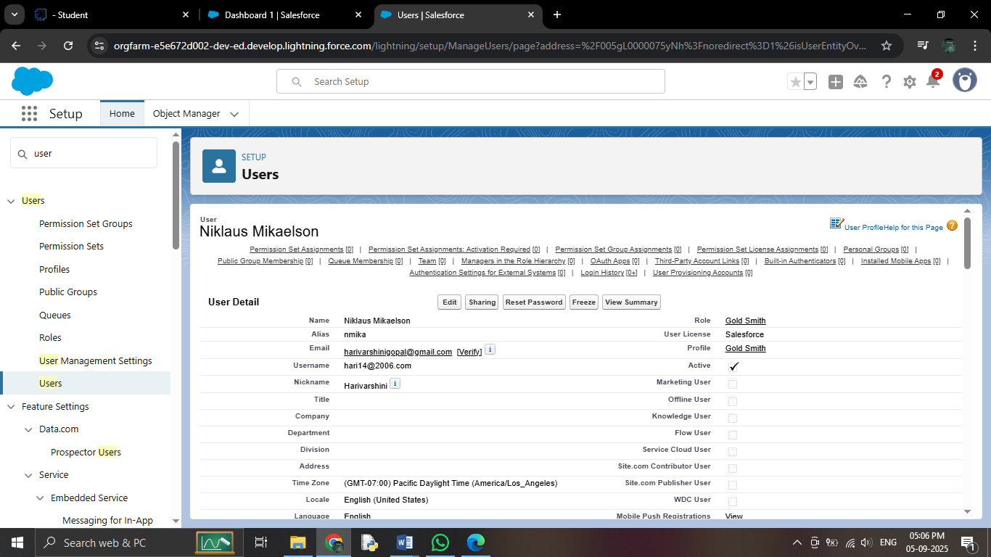

1. **Save**:
   * Once you've filled in all the fields, click **Save** to create the user.

**ACTIVITY 2: Create User**

1. **Go to Setup**:
   * In Salesforce, click on **Setup** (top-right corner).
2. **Search for Users**:
   * In the **Quick Find** box, type **Users** and click on **Users** under the "User Management" section.
3. **Create New User**:
   * On the Users page, click on **New User** (usually a button at the top of the page).

### C:\Users\Admin\Pictures\Screenshots\Screenshot (15).png

1. **Fill in the User Details**:
   * **First Name**: Type **Kol**.
   * **Last Name**: Type **Mikaelson**.
   * **Alias**: Enter an alias (a short name, like **KolM** or **K.M**).
   * **Email ID**: Enter your personal email address (for example, **kol.m@example.com**).
   * **Username**: Enter a username in this format: **kol.mikaelson@example.com**.
   * **Nickname**: Enter a nickname (like **Kol** or **KM**).
   * **Role**: Choose **Worker** (from the dropdown).
   * **User License**: Select **Salesforce Platform**.
   * **Profile**: Choose **Worker** (from the dropdown).
2. **Save**:
   * After filling in the details, click **Save** to create the user.

**PHASE 4:** Data Migration, Testing & Security

**Milestone 8: PAGE LAYOUT**

**ACTIVITY 1:To Create A Gold Page layout**

1. **Go to Setup**:
   * In Salesforce, click the gear icon in the top-right corner, then click **Setup**.
2. **Find Object Manager**:
   * In the left-hand search box, type **Object Manager** and click on it.
3. **Search for the Object**:
   * In the **Object Manager** page, type **Item** (or the name of your object) in the search bar and click on it.
4. **Edit the Object**:
   * In the **Item** object page, click **Edit** in the dropdown.
5. **Create a New Page Layout**:
   * Click on **Page Layouts** on the left side.
   * Now, click the **New** button to create a new layout.

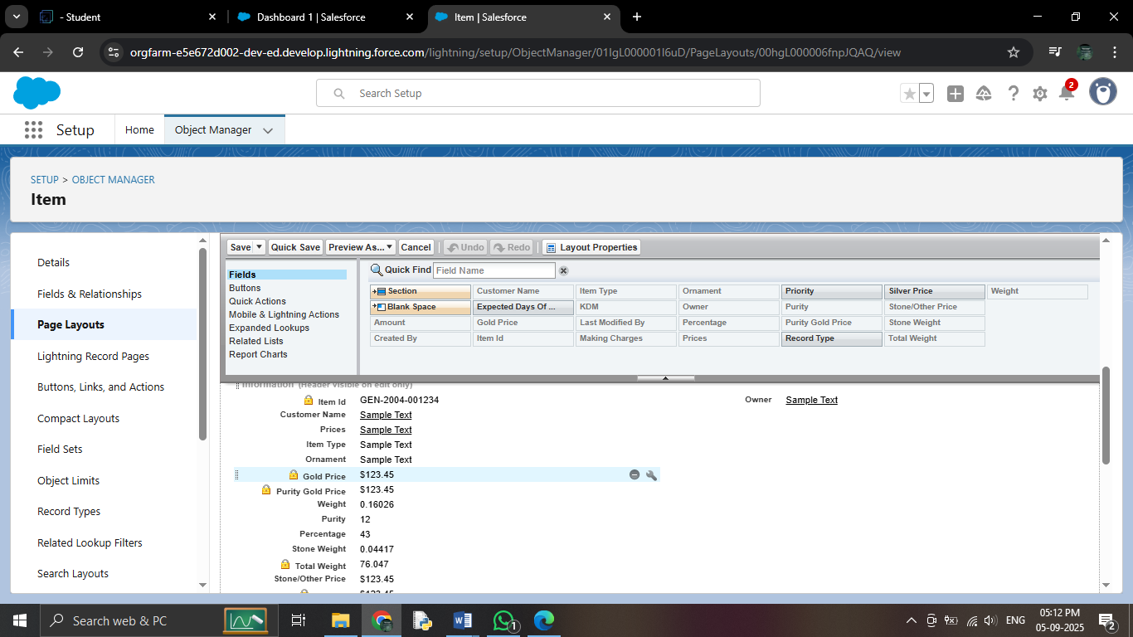

1. **Name the Layout**:
   * In the pop-up window, name your new layout **"Page Layout for Gold"**.
   * Then, click **Save and New**.
2. **Save the Layout**:
   * Once you’ve made all changes and arranged the fields, click **Save**.

**ACTIVITY 2:To Create A Silver Plate Layout**

1. Go to Setup:
   * Click the gear icon at the top-right of Salesforce.
   * Select Setup from the dropdown.
2. Find Object Manager:
   * In the Quick Find box on the left, type Object Manager and click on it.
3. Edit the Object:
   * Once on the Item page, click the dropdown next to it and select Edit.
4. Create a New Page Layout:
   * In the left sidebar, click on Page Layouts.
   * Click the New button to create a new layout.

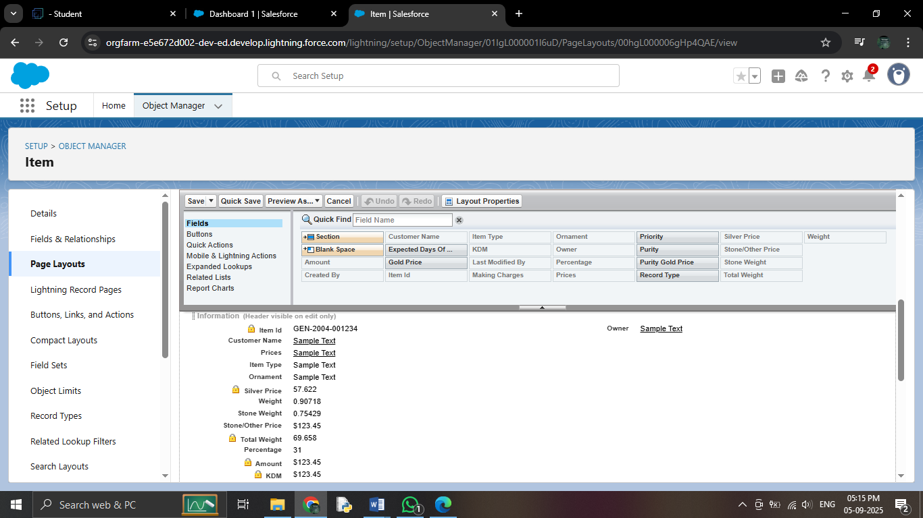

1. Name the Layout:
   * When the pop-up appears, name your layout "Page Layout for Silver".
   * Then, click Save.
2. Arrange the Fields:
   * Now, you’ll see the layout editor. Arrange the fields as shown in the Information Section (based on your requirements).
   * Remove the fields related to Gold by clicking on the "X" next to them (or using the Remove button).
   * After adjusting everything, click OK.
3. Save the Layout:
   * When you're done, click Save to finalize the layout.

## Milestone 9: PAGE LAYOUT

# Activity 1: Create a Record Type for Gold

**1.** Go to Setup

* Click the gear icon in the top-right corner of Salesforce.
* Select Setup from the dropdown.

2. Find the Object

* In the Quick Find box on the left, type the name of your object (e.g., Item) and click on it.

3. Create a New Record Type

* On the left sidebar, click Record Types.
* Click New to create a new record type.

4. Fill in Record Type Details

* Select Existing Record: Choose Master (this is the default record type for the object).
* Record Type Label: Enter "Gold".
* Description: Enter "Gold items information" (this helps users know what this record type is for).
* Uncheck "Make Available": This means you're not making the Gold record type available to everyone yet.
* Click Next.

5. Assign to Profiles

* Scroll down and check the boxes for Gold Smith, Worker JW, and System Administrator profiles. These are the people who will use the Gold record type.
* Click Next.

6. Apply Page Layout for Each Profile

* Select "Apply a different layout for each profile".
* For each profile (Gold Smith, Worker JW, and System Administrator), change the Page Layout to "Page Layout for Gold".
* Click Save & New if you want to create another record type (for Silver).

# Activity 2: Create a Record Type for Silver

1. Create Another Record Type

* Repeat the same steps as in Activity 1 to create a new record type.
* For the Record Type Label, enter "Silver".
* For the Description, enter "Silver items information".

2. Assign Profiles for Silver

* Scroll down and check the boxes for the same profiles (Gold Smith, Worker JW, System Administrator).
* Click Next.

3. Apply Silver Layout

* Apply a different layout for each profile.
* For each profile, change the Page Layout to "Page Layout for Silver".
* Click Save.

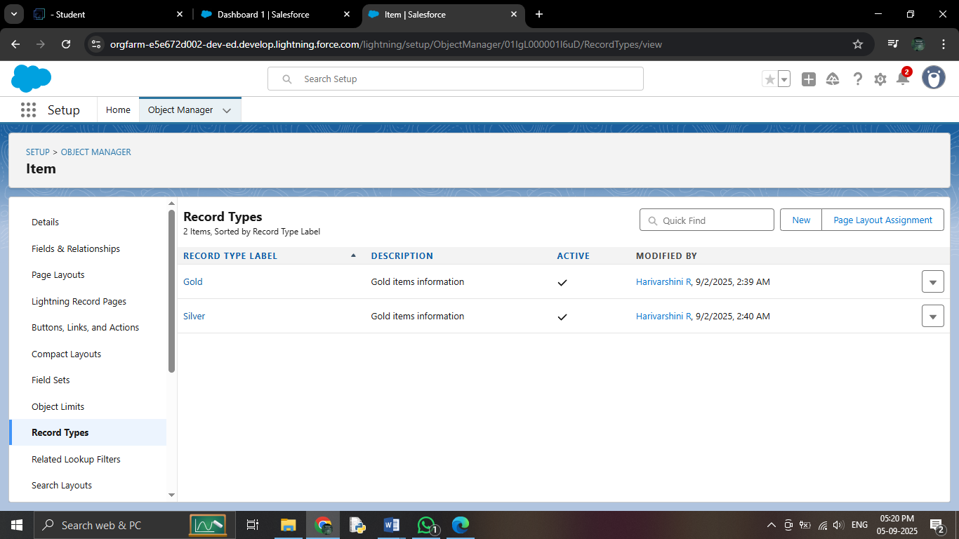

Milestone**: 10 PERMISSION SETS**

**ACTIVITY 1:Creating Permission Sets**

1. Go to Setup

* Click the gear icon in the top-right corner of Salesforce.
* Select Setup.

2. Search for Permission Sets

* In the Quick Find box on the left, type "Permission Sets" and click on it.

3. Create a New Permission Set

* Click the New button to create a new permission set.

4. Fill in the Permission Set Details

* Label: Enter the label name as "Per to Worker".
* API Name: This will auto-populate once you enter the label.
* save

**Configure Object Settings in the Permission Set**

5. Select Object Settings

* Under the **Apps** section on the left, click **Object Settings**.

6. Choose the Items Object

* Click on the Items object.
* Click the Edit button.

7. Enable Record Types (Gold and Silver)

* In the Item: Record Type Assignments section, enable Gold and Silver record types.

8. Set Object Permissions

* Under Object Permissions, check the boxes for Read, Edit, and Create.

9. Save the Permission Set

* Click **Save** to save these settings.

**Assign Permission Set to Users**

10. Manage Assignment

* After saving the permission set, click Manage Assignments.

11. Add Assignment

* Click Add Assignment.

12. Select Users

* Find and select the users you created in the User Milestone who have the Worker profile.
* Click Next, then click Assign.

13. Finish

* After assigning the permission set, click Done.

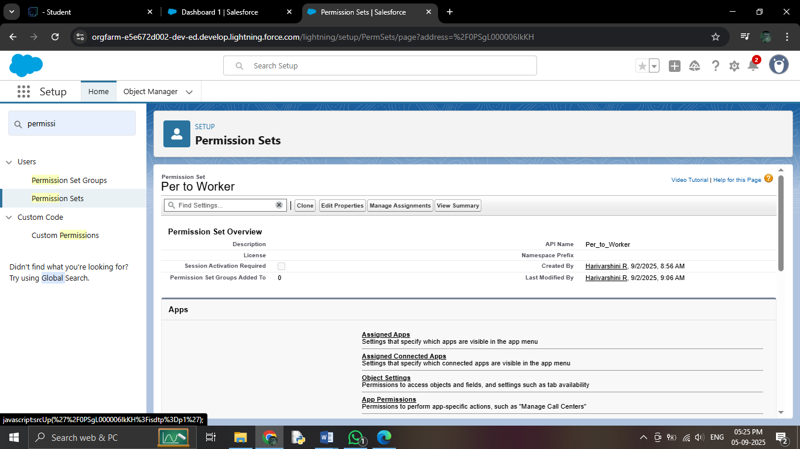

**Milestone 11: TRIGGER**

**ACTIVITY 1: Create A Trigger Handler Class**

**Code:**

 public class UpdatePaidAmountTriggerHandler {

    public static void handleBeforeInsert(List<Billing\_\_c> newBillings) {

        for (Billing\_\_c billing : newBillings) {

            billing.Paid\_Amount\_\_c = billing.Paying\_Amount\_\_c;

        }

    }

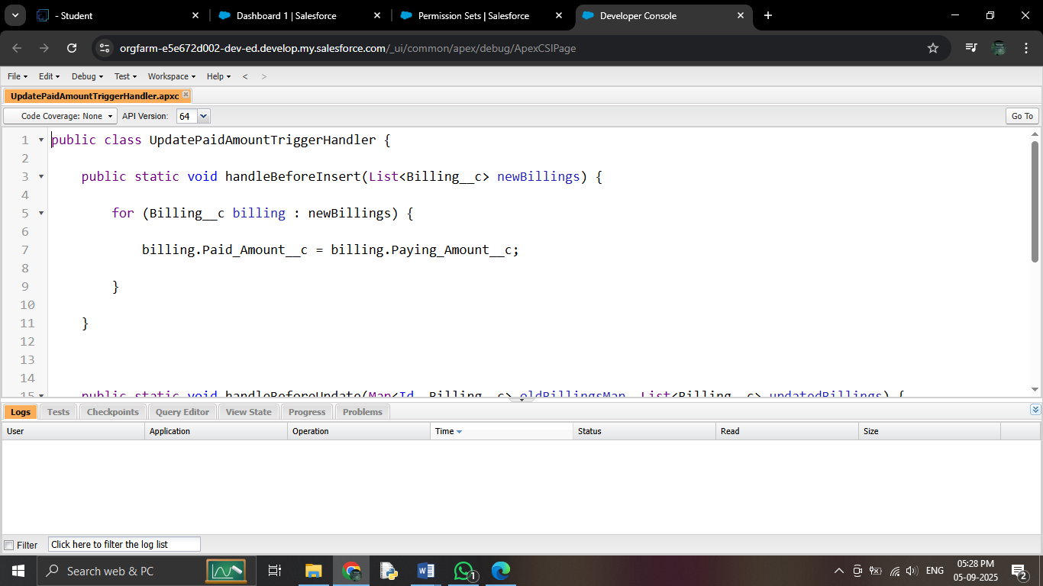

ACTIVITY 2 :Create The Trigger

**Code:**

trigger UpdatePaidAmountTrigger on Billing\_\_c (before insert, before update) { if (Trigger.isInsert) {

UpdatePaidAmountTriggerHandler.handleBeforeInsert(Trigger.new);

} else if (Trigger.isUpdate) { UpdatePaidAmountTriggerHandler.handleBeforeUpdate(Trigger.oldMap, Trigger.new);

}

}

### C:\Users\Admin\Pictures\Screenshots\Screenshot (21).png

### Milestone 12: USER ADOPTION

### ACTIVITY 1: Create a Record (Jewel Customer)

1. Click on App Launcher:  
   On the left side of your screen, you'll see an icon called the App Launcher (it might look like a grid of dots). Click on it to open a list of all the apps in your system.
2. Search for "Jewelry Inventory System":  
   In the search bar, type "Jewelry Inventory System" and click on it once it appears in the search results. This opens the app.

Click on Drop Down and Select "Jewel Customer" Tab:  
Inside the Jewelry Inventory System app, you'll see a drop-down menu or list of tabs at the top. Click on the drop-down, and from the list, choose the Jewel Customer tab. This tab is where you can manage your customer information.

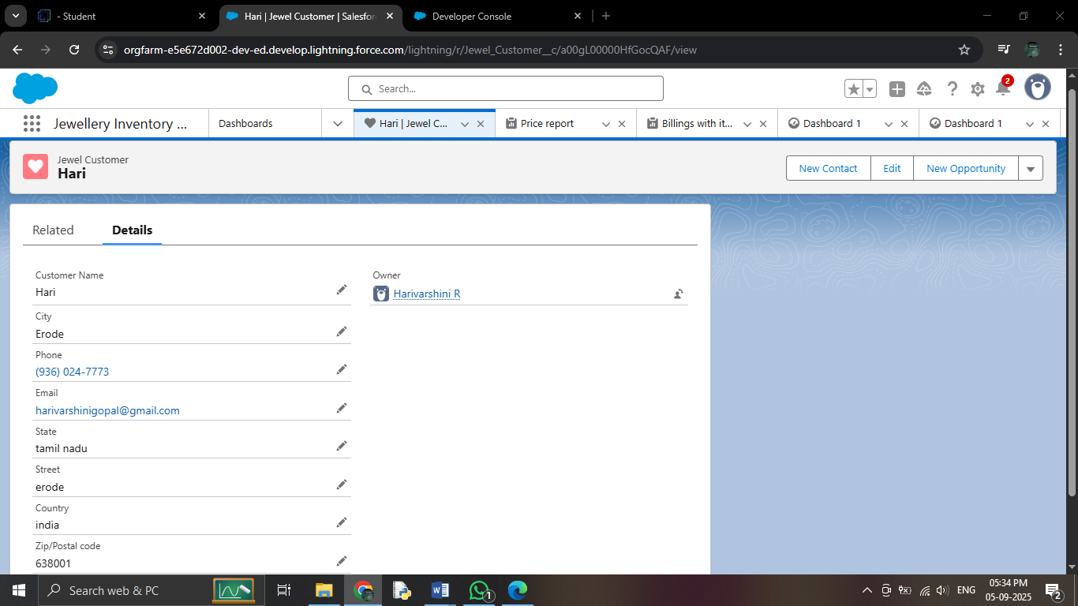

1. Click "New":  
   After you've selected the Jewel Customer tab, look for a button that says New (usually at the top of the screen). Click this to create a new customer record.
2. Fill in the Details:  
   A form will appear asking you to enter customer details (such as name, contact info, etc.). Fill out the form with the required information.
3. Click Save:  
   After entering all the customer details, click the Save button to store the information in the system.

### ACTIVITY 2:View A Record(Jeweller Customer)

1. Click on App Launcher:  
   On the left side of your screen, click the App Launcher icon (a grid of dots) to open a list of apps.
2. Search for "Jewelry Inventory System":  
   In the search bar, type "Jewelry Inventory System" and select it from the search results. This will open the Jewelry Inventory System app.
3. Click on the Jewel Customer Tab:  
   Inside the Jewelry Inventory System app, you’ll see a list of tabs at the top. Click on the Jewel Customer tab. This will show you a list of all customer records.

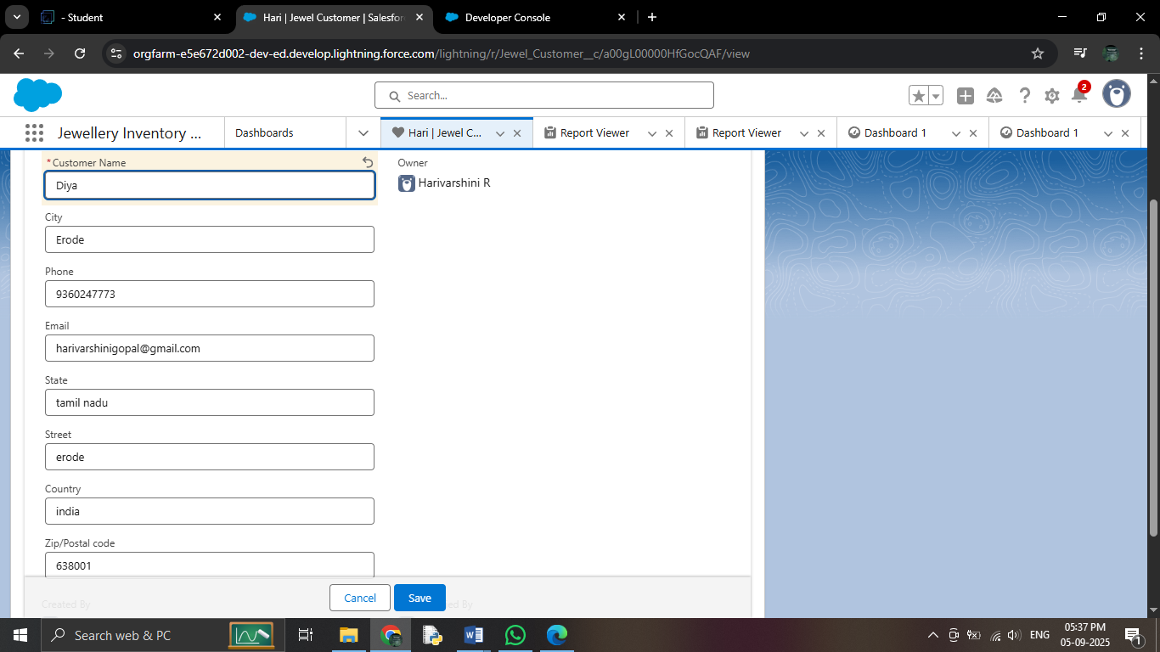

### ACTIVITY 3:Delete A Record(Jewellry Customer)

### To **Delete a Jewel Customer Record**:

1. **Click on App Launcher**:  
   On the left side of your screen, click the **App Launcher** icon (grid of dots) to open the list of apps.
2. **Search for "Jewelry Inventory System"**:  
   In the search bar, type **"Jewelry Inventory System"** and click on it to open the app.
3. **Click on the Jewel Customer Tab**:  
   Inside the Jewelry Inventory System app, you’ll see a set of tabs. Click on the **Jewel Customer** tab to view the list of customer records.
4. **Click on the Arrow**:  
   Find the record you want to delete. On the right side of the record, you’ll see an **arrow** (or a dropdown). Click on that arrow.
5. **Click Delete**:  
   In the dropdown menu, click **Delete**. This will remove that customer record from the system.

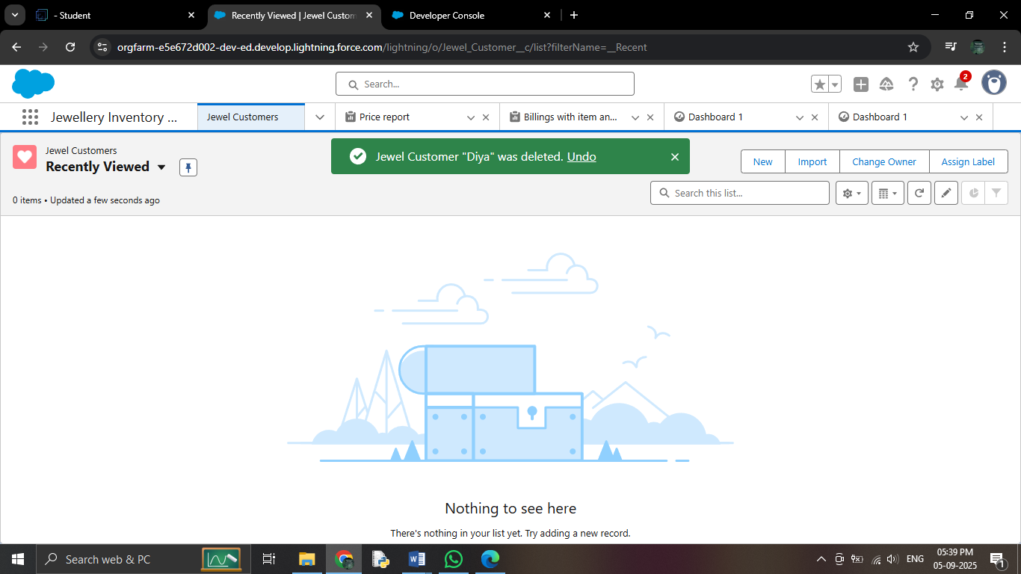

### PHASE 5: Deployment, Documentation & Maintenance

# Milestone 13:REPORTS

# ACTIVITY 1:Create Report

# Open the App: Go to the app and find the Reports tab.

1. Create a New Report: Click on New Report to start creating a report.
2. Select Report Type:
   * You can choose a report type by browsing categories.
   * Alternatively, you can search for a specific report type.
   * Once you find what you're looking for, click Start Report.
3. Customize Your Report:
   * You'll be able to add specific fields (or data) to the report. These fields are shown on the left side of the screen.
   * Pick the fields you need and drag them into the report.
4. Save or Run the Report:
   * Once you're happy with the report, either save it for future use or run it to generate the data.

# 

### ACTIVITY 2:REPORTS

### ****1****. Create a Report with "Item with Billings":

### 2. ****Create a Report with "Billings with Item and Customer Order"****:

* Again, go to the **Reports tab** and click **New Report**.
* Search for or select **"Billings with Item and Customer Order"** as the report type.
* Click on **Start Report**.
* Customize it by adding the fields you want (e.g., billing details, items sold, customer orders, etc.).
* After setting it up, **save or run** the report.

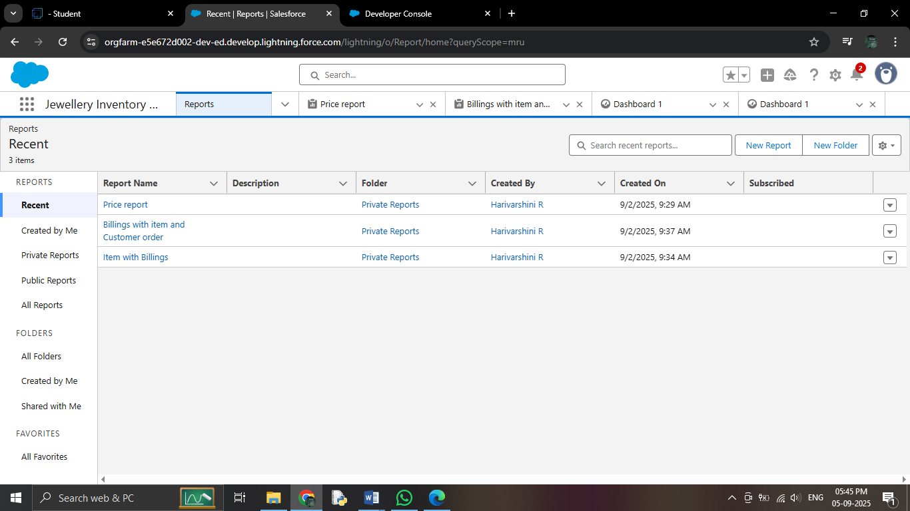

### Milestone 14: DASHBOARDS

### Activity 1: Create a Dashboard

1. **Open the App**: Go to the app and click on the **Dashboards tab**.
2. **Create a New Dashboard**:
   * Give your dashboard a **name** (e.g., "Sales Overview").
   * Click on **Create**.
3. **Add a Component**:
   * After creating your dashboard, click on **Add Component**.
4. **Select a Report**:
   * Choose a **report** that you want to display on the dashboard (e.g., "Item with Billings").
   * Click **Select** to choose the report.
5. **Add the Report**:
   * After selecting the report, click **Add** to add it to the dashboard.
6. **Save the Dashboard**:
   * Click on **Save** to save the dashboard.
   * Once saved, click **Done** to finish.

### ****Activity 2: Create Another Dashboard (Repeat Steps from Activity 1)****

* Repeat the same steps as in **Activity 1** to create another dashboard.
* Give it a different name, add a component (report), save it,

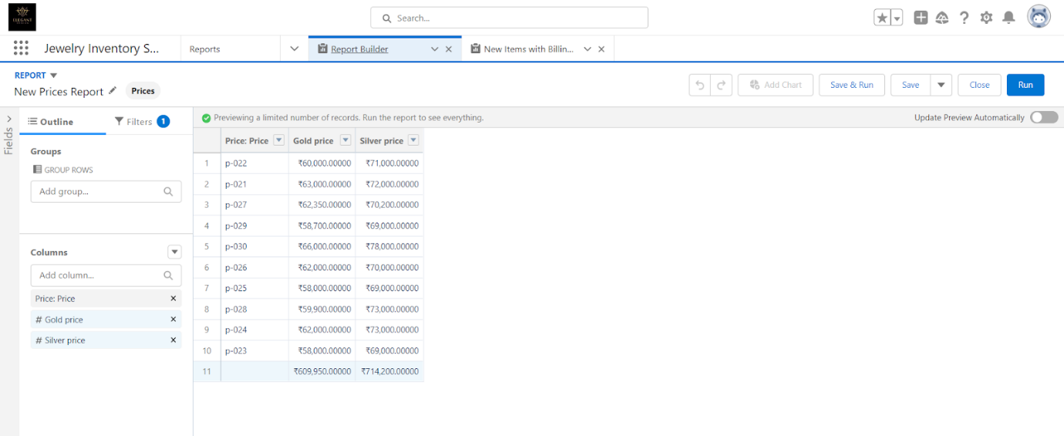

### Milestone 15:FLOWS

# ACTIVITY 1:CREATE A FLOW

**Steps to Create a Flow in Salesforce:**

1. **Go to Setup**:
   * Open **Setup** in Salesforce.
   * In the **Quick Find box**, type **"Flow"** and click on **Flow**.
2. **Create a New Flow**:
   * Click on **New Flow**.
   * Select **Record-triggered Flow** and click **Create**.
3. **Choose the Object**:
   * From the **Object** dropdown, select **"Billing"**.
   * Set the flow trigger to **"A record is Created or Updated"**.
   * Under **Optimize the flow for**, select **"Actions and Related Records"**.
   * Click **Done**.
4. **Switch to Free-form Layout**:
   * Change the flow layout from **Auto-layout** to **Free-form** by selecting it.
5. **Create a Text Template**:
   * In the **Toolbox**, find the **Manager** option and click on **New Resource**.
   * Choose **Text Template** as the resource type.
   * Enter the **API Name** as **"Email Body"**.
   * Change the **View** from **Rich Text** to **Plain Text**.
   * In the **Body** field, paste the following syntax:

* **Hello**
* **Customer Name: {!$Record.Item\_\_r.Customer\_Name\_\_r.Name}**
* **Here are the details for the item you purchased with Jewellery Inventory System:**
* **Item Type: {!$Record.Item\_\_r.Item\_Type\_\_c}**
* **Ornament: {!$Record.Ornament\_\_c}**
* **Weight: {!$Record.Weight\_\_c} grams**
* **Amount: {!$Record.Amount\_\_c}**

Click **Done**.

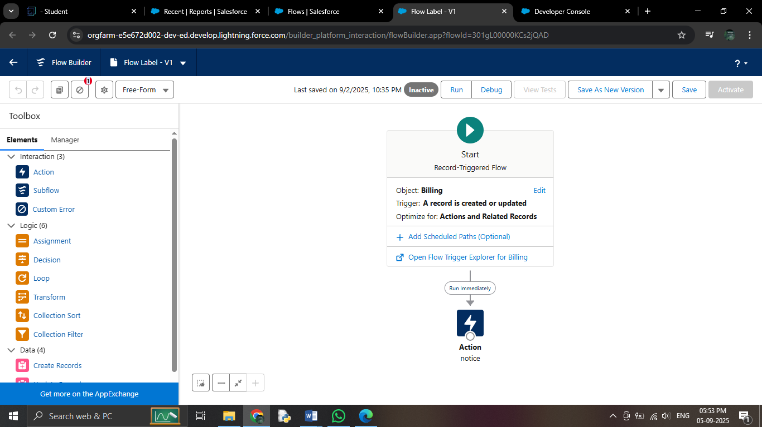

**Add an Action to Send an Email**:

* + In the **Elements** section, drag the **Action** element to the flow canvas.
  + In the action search bar, search for **"Send Email"** and click on it.
  + Set the **Label** as **"Notice"** (the API name will auto-populate).
  + Enable the **Body** field and set the value to the **Text Template** you just created.
  + For **Recipient Address**, select the email field from the record ({!$Record.Item\_\_r.Customer\_Name\_\_r.Email\_\_c}).
  + Set the **Subject** to **"Welcome to Jewelry Inventory System"**.
  + Click **Done**.

1. **Connect the Flow Elements**:
   * Drag a **Path** from the **Start** element to the **Action** element.
2. **Save and Activate the Flow**:
   * Click **Save** and give your flow a **Label**. The **API Name** will be auto-populated.
   * Finally, click **Activate** to turn the flow on.

**CONCLUSION:**

By leveraging the Salesforce platform, the project successfully established an efficient, transparent, and user-friendly system for managing jewellery inventory, customer relationships, and sales operations. Through streamlined workflows and real-time coordination among staff, suppliers, and customers, the project significantly improved operational efficiency and customer experience.

The project **“Jewellery Management System using Salesforce CRM”** has been successfully implemented and highlights the effective use of Salesforce technology in automating and optimizing business processes within the retail jewellery sector.

### **PROJECT ACHIEVEMENTS:**

* **Streamlined Inventory Management**: Simplified tracking and management of jewellery stock across multiple categories and locations.
* **Automation of Business Processes**: Implemented custom objects, Flows, and Apex triggers to automate tasks such as order processing, stock alerts, and billing.
* **Improved Reporting & Analytics**: Leveraged dashboards and reports to gain real-time insights into sales, customer behavior, and inventory turnover.
* **Secure Role-Based Access**: Ensured data security and usability with a customized Lightning App, Home Page, and role-specific permissions

### **STUDENT LEARNING OUTCOMES:**

* **Hands-On CRM Customization**: Gained practical experience in developing custom Salesforce objects, workflows, and automation.
* **Business Process Understanding**: Learned how to map real-world jewellery business processes into CRM systems.
* **Team Collaboration**: Collaborated effectively in requirements gathering, system design, development, and testing.
* **Professional Tool Exposure**: Worked with industry-standard tools and methodologies, enhancing readiness for enterprise environments.

**FUTURE SCOPE:**

* **Mobile App Integration**: Enable mobile access for sales staff and customers to view inventory and manage orders on the go.
* **AI & Analytics**: Use predictive analytics to forecast customer buying trends and manage stock efficiently.
* **Third-Party Integration**: Connect with ERP systems, payment gateways, and e-commerce platforms for end-to-end business automation.
* **Scalability Across Branches**: Expand the system for use across multiple store locations, ensuring centralized management and reporting.